OME NEWS

A high school basketball coach is still out $10,000 after Southwest canceled a flight and left his whole team stranded in Las Vegas for 5 days over Christmas. They ended up chartering a bus to drive 18 hours home in the snow.
Kelsey Vlamis
Jan 29, 2023, 8:47 AM
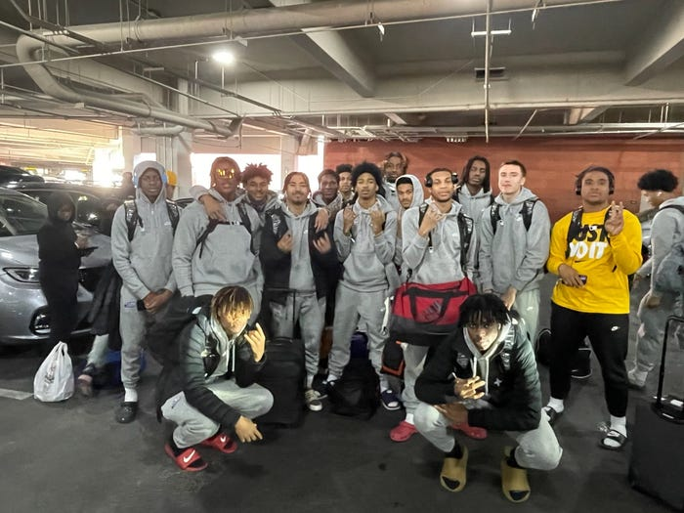
The Rainier Beach High School boys basketball team. Virginia Bethea
- A Seattle high school basketball team spent Christmas in Vegas after a canceled Southwest flight.
- The coaches spent days and thousands of dollars taking care of the players and trying to get them home.
- In the end, a businessman paid nearly $15,000 to charter a bus to bring them home.

An entire high school basketball team from Seattle, Washington, ended up stranded in Las Vegas for five days over Christmas after Southwest canceled their flight and left them scrambling to get home, spending thousands of dollars, and eventually driving 18 hours on a bus through the snow.
The Rainer Beach High School team, a powerhouse that has produced several NBA players under its current coaching staff, was in Las Vegas for the Tarkanian Classic, an elite annual tournament attended by NBA executives and scouts.
The trip was planned months in advance for December 19 to 23 and was attended by more than 30 people, including 15 players, coaching staff, and some parents. But in the early morning of December 23, just hours before it was time to head to the airport, they got a text from Southwest Airlines saying their flight was canceled.
"In most cases, the airline would go ahead and reschedule you," Michael Bethea, the team's head coach, told Insider. "When I contacted the airline, it was basically, to sum it up, 'You're on your own.'"
Bethea and his wife, Virginia Bethea, who also works at the school as a family support specialist, would spend the next five days traveling back and forth from the airport, trying to get the boys on flights home to Seattle, and in the meantime covering costs of the hotel rooms, rental cars, and food. The couple said altogether they spent over $10,000.
Other coaches, including assistant coach Harold Wright, also spent money and time taking care of and feeding the players, who were often sprawled out in the hotel lobby waiting to find out if they'd make it home for Christmas. Meanwhile, some of the parents and coaches were worried about losing their jobs due to missing work.
After many hours of trying to get help from the airline, Southwest said it could try splitting up the team and getting them out on separate flights — but not necessarily to Seattle.
"They were going to put us on flights to nowhere. They were going to send eight kids to Phoenix with no connecting flight to Seattle, eight kids to Sacramento with no connecting flights," Bethea said. "So I said, 'That's your answer? What are they supposed to do once they get there?"
"Well, we're getting them on planes," Southwest responded, according to Bethea.
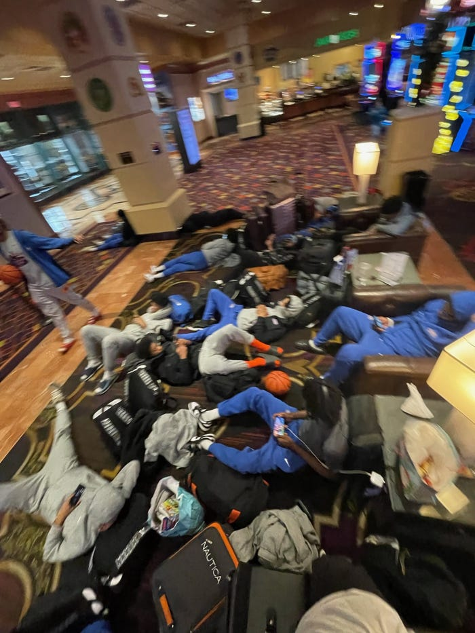
The Rainier Beach High School boys basketball team stuck in Vegas. Virginia Bethea
Eventually, they worked out a situation to send the players on flights to Seattle in groups, each accompanied by an adult, on separate planes and even separate days, but every one of those flights also got canceled.
Finally, after being stuck in Vegas over Christmas and being told by Southwest the earliest they could fly out was December 31 — more than a week after their initial flight — the Betheas spoke to a friend of theirs and a local businessman from back home who wanted to help.
"He was like, 'I just want to get those kids home safely,'" Virginia Bethea said. "And he doesn't even know these kids."
The man paid nearly $15,000 to charter a bus, which they got at a discount, to drive the entire team, staff, and family members 18 hours home to Seattle, at times through the snow and sketchy road conditions, on December 28.

'We're really going to miss Christmas with our families?'
When the original flight was first canceled, the coaches initially tried to be optimistic that the team would still make it home for Christmas. But reality eventually sunk in. During a team meeting, one of the coaches with two kids in grade school had to walk out of the room because they were crying.
"A lot of the kids were honestly in disbelief, like, 'We're really going to miss Christmas with our families?'" Bethea said.
Still, the team tried to make the most of the situation, including by taking everyone to a buffet dinner on Christmas day. Michael and Virginia Bethea even went out and bought each of the kids a Christmas gift.
"It kind of brightened up everybody's attitude," assistant coach Wright said. "They still felt like they were worthy of something."
"Christmas is a big deal for most of these kids," he explained, adding that it's the first time they get new sneakers or other things.
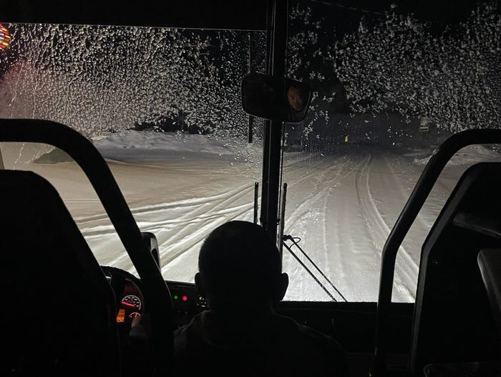
The team took a bus 18 hours home to Seattle, driving through snowy roads. Virginia Bethea
Even though the coaches also missed their family Christmas plans, they said there were a lot of positives to come out of the situation.
"This is probably the best Christmas, in all honesty," Virginia Bethea said, adding "just to be able to serve people through this time. This is what Christmas is all about."
Wright said he also enjoyed getting to spend additional time with the players, becoming even more of a family and helping them feel better through tough circumstances.
"That's what I was trying to project into them: That through adversity, we can still manage a good situation," Wright said. "'Keep your heads up and we're going to get through this, but we're going to have to do it together."

The team will take more trips, but likely not on Southwest
As of Friday, the team had been partially refunded for the canceled flights but was still waiting on the full amount. They also said they were told they would be able to get some of the incidental expenses covered, but have not been told how much.
"The refunds for the team's outbound flights that were interrupted are in process for a full refund and the reimbursements are currently being reviewed for consideration," a spokesperson for Southwest told Insider, adding: "We continue to process requests daily to help make things right for this group of Customers and the others whose travel plans were disrupted."
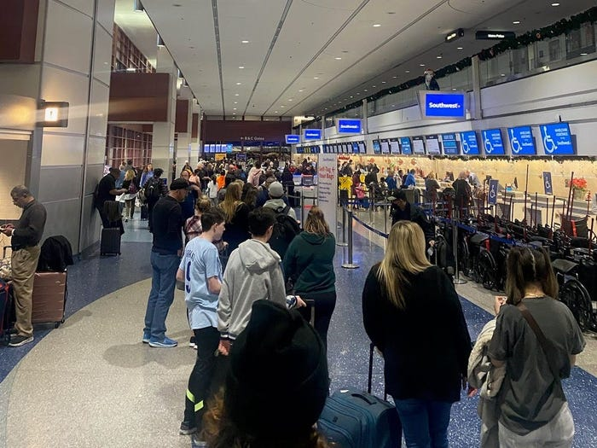
The Betheas said the line to talk to a Southwest agent spanned the length of the terminal. Virginia Bethea
The team was among thousands of travelers across the country who experienced canceled flights over Christmas. Secretary of Transportation Pete Buttigieg has said airlines were required to issue refunds "within seven business days if a passenger paid by credit card, and within 20 days if a passenger paid by cash, check, or other means." He also called on them to cover ground transportation, hotels, and meals for stranded passengers.
The coaches said that when the initial flight was canceled, they struggled to even get a Southwest customer service agent on the phone. When they finally did, the agent apologized but didn't have any answers. Bethea said the first person he talked to spoke with him, and hung up on him, in two separate calls, and then: "The third time I called him he said, 'Is this Mr. Bethea?' I said, 'Yes.' And he hung up on me."
He said the team will continue to travel for national tournaments every year. They stressed the success of the school's basketball program under coach Bethea and assistant coach Wright, who have coached at the school for 28 years, and the opportunities it's provided the players.
"They put more Black boys in college than all high school basketball programs combined in the state of Washington," Virginia Bethea said. Her husband added that the program has been responsible for millions of dollars in educational scholarships that players have received.

