
BCANY Summer Hoops Festival
2026 Game Schedule

 | Monroe-Woodbury HS - Main Gym | Monroe-Woodbury HS - Auxiliary Gym | Monroe-Woodbury  Middle School | Central Valley Elementary School
Friday - August 7
2:00pm | Boys Nassau vs  Hudson Valley | Girls Hudson Valley vs  Nassau | Boys Mid-Hudson vs  Suffolk | Boys Capital vs  Southern Tier
3:30pm | Girls Rochester vs  Mid-Hudson | Boys Central vs  North Country | Girls Buffalo vs  Suffolk | Girls Capital vs  Southern Tier
5:00pm | Boys Mid-Hudson vs  Rochester | Girls Nassau vs  Central | Boys Buffalo vs  Nassau
6:30pm | Girls Southern Tier vs  Mid-Hudson | Boys Southern Tier vs Hudson Valley | Girls Buffalo vs  Rochester | Girls Hudson Valley vs Suffolk
8:00pm | Boys Buffalo vs  Capital | Boys Central vs  Rochester | Girls Central vs  Capital | Boys Noth Country vs  Suffolk
Saturday – August 8
9:00am | Boys North Country vs  Mid-Hudson | Girls Southern Tier vs  Suffolk
10:30am | Girls Rochester vs  Nassau | Boys Southern Tier vs  Buffalo | Boys Capital vs  Hudson Valley
12:00pm | Boys Suffolk vs  Rochester | Boys Mid-Hudson vs  Central | Girls Buffalo vs  Hudson Valley | Girls Mid-Hudson vs  Central
1:30pm | Slam Dunk and Three-Point Contest (Monroe-Woodbury HS – Main Gym)
2:30pm | Girls Capital vs  Nassau | Boys Nassau vs  Capital | Girls Rochester vs  Southern Tier | Boys Hudson Valley vs Buffalo
4:00pm | Girls Suffolk vs  Central | Boys Central vs  Suffolk | Boys Rochester vs  North Country
5:30pm | Boys Nassau vs  Southern Tier | Girls Buffalo vs  Capital | Girls Mid-Hudson vs  Hudson Valley
Sunday – August 9
9:00am | Boys A1 vs B2 Semifinal | Boys A2 vs B1 Semifinal | Boys A5 vs B5
10:30am | Girls Semifinal | Girls Semifinal | Girls 5th Place Game
12:00pm | Boys Championship | Boys A3 vs B3 | Boys A4 vs B4 | Girls 7th Place Game
1:30pm | Girls Championship
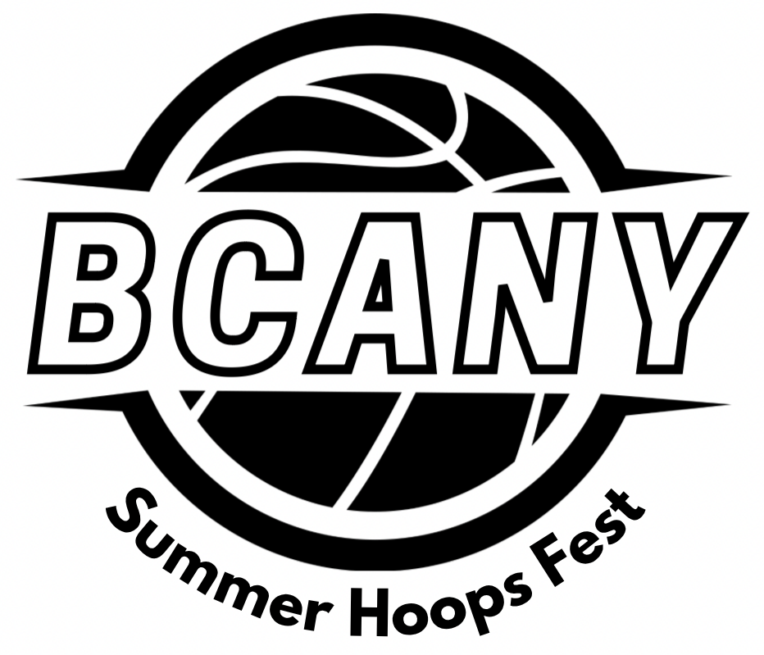

Girls Pool A: Rochester, Southern Tier, Mid-Hudson
Girls Pool B: Suffolk, Hudson Valley, Buffalo
Girls Pool C: Central, Capital, Nassau

Boys Pool A: Rochester, Central, Suffolk, Mid-Hudson, North Country
Boys Pool B: Capital, Buffalo, Southern Tier, Hudson Valley, Nassau

