High School Girls Basketball Team Quits After Crowd Allegedly Spews Racial Slurs
Edith Olmsted
Tue, February 13, 2024 at 6:43 PM EST·2 min read
640
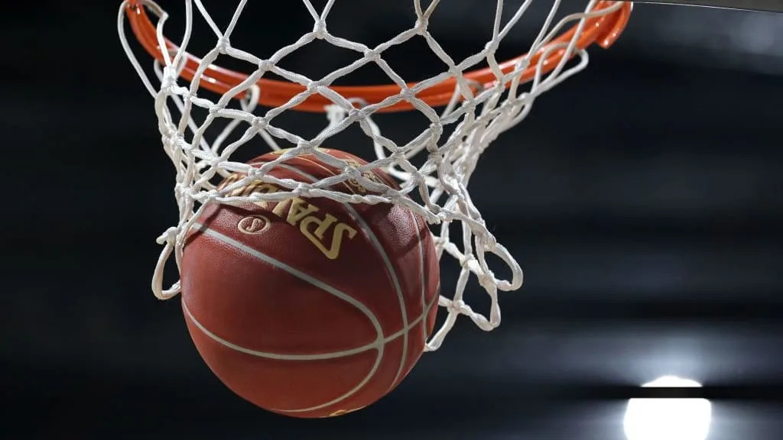
Inaki Esnaola/Getty Images
A high school girls’ basketball game in Scarsdale, New York came to an early finish on Saturday when the visiting team from East Ramapo walked off the court as attendees unleashed an onslaught of racial slurs.
East Ramapo Superintendent Clarence G. Ellis condemned the incident in a statement on Monday, obtained by the Rockland/Westchester Journal News.
“The use of racial epithets and other bigoted language meant to hurt someone based on their skin color have no place in high school athletics or anywhere in our community,” he said.
School officials in both districts have since announced investigations into the incident.
Athletic directors Ray Pappalardi in Scarsdale and Greg Russo in East Ramapo released a joint statement saying that they had “not identified a specific individual or group who engaged in any inappropriate conduct.”
“Unfortunately, the game ended, the East Ramapo players left Scarsdale feeling dejected and disrespected, and a day intended to bring communities together for a common purpose was tainted,” they said. The game was part of an event to fund breast cancer research done by the V Foundation, a charitable group founded by ESPN and legendary college basketball coach and broadcaster Jim Valvano.
Dejane Buckley, a point guard for East Ramapo, attended the game to support her team despite the fact that she is still healing from an ACL injury. The sophomore at Spring Valley—one of the two schools that makes up East Ramapo’s Titans—told the Journal News that a Scarsdale player barked at her teammates, while the coach laughed. Shortly after the East Ramapo coach “realized that from the stands they were saying ‘Black N-words,’” Buckley said.
“We forfeited, we didn’t want to continue to play in that kind of environment,” Buckley added, claiming that the slurs continued as she and her teammates walked off the court.
More than 11,000 students are enrolled in schools in East Ramapo, 75 percent of which are are Hispanic or Latino. Just 18 percent are African American, according to district statistics.
At Scarsdale where the two teams played on Saturday, only 8% of students are Hispanic or Latino and 1% are Black or African American.

