Girls basketball: BCANY, OCIAA all-stars for 2022-23 season
Ken McMillan
Times Herald-Record
0:18
1:26
Paige Girardi of Warwick, Zoe Mesuch of Wallkill, Allison Bono of Chester, Shannon Sgombick of S.S. Seward and Natalie Fox of Millbrook were named class all-stars for Section 9 by member coaches of the Basketball Coaches Association of New York for the 2022-23 season.
The BCANY coaches of the year were Dave Powers of Monroe-Woodbury, A.J. Higby of Wallkill, Lindsay Rock of Chester and Joe DiMattina of S.S. Seward.
Coaches from the Orange County Interscholastic Athletic Association picked all-stars but not division MVPs.

BCANY Section 9 all-stars
Class AA
Player of year: Paige Girardi (Warwick)
Coach of year: Dave Powers (Monroe-Woodbury)
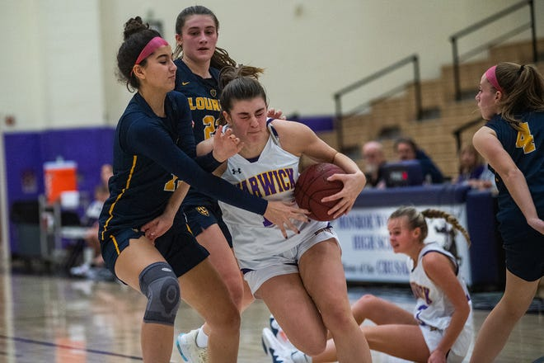
All-stars: Kingston – Diamond Banks, Jr.; Asia Lebon, Jr.; Ava Scaturro, Soph.; Our Lady of Lourdes – Simone Pelish; Middletown – Ashley MacCalla, Eighth; Monroe-Woodbury – Arianna Exarchakis, Sr.; Madison Fileen, Sr.; Olivia Shippee, Sr.; Newburgh Free Academy – Terri-Nashjae (Tiki) Burden, Fr.; Pine Bush – Ketura Rutty, Soph.; Jah-esa Stokes, Jr.; Valley Central – Giselle Johnson, Fr.; Warwick – Megan Desrats, Sr.; Paige Girardi, Sr.; Kaitlyn Larney, Soph.
Class A
Player of year: Zoe Mesuch (Wallkill)
Coach of year: A.J. Higby (Wallkill)
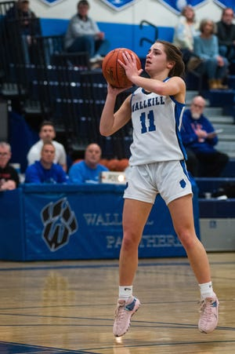
All-stars: Beacon – Reilly Landisi, Soph.; Daveya Rodriguez, Soph.; Cornwall – Maliha Yunker, Jr.; Goshen – Peyton Andryshak, Sr.; Monticello – Aaliyah Mota, Sr.; F.D. Roosevelt – Nkiru Awaka, Sr.; Yadi Smith, Sr.; Saugerties – Molly Boek; Natalie Tucker; Wallkill – Alex Dembinsky, Jr.; Zoe Mesuch, Soph.; Emma Spindler, Sr.
Class B
Player of year: Allison Bono (Chester)
Coach of year: Lindsay Rock (Chester)
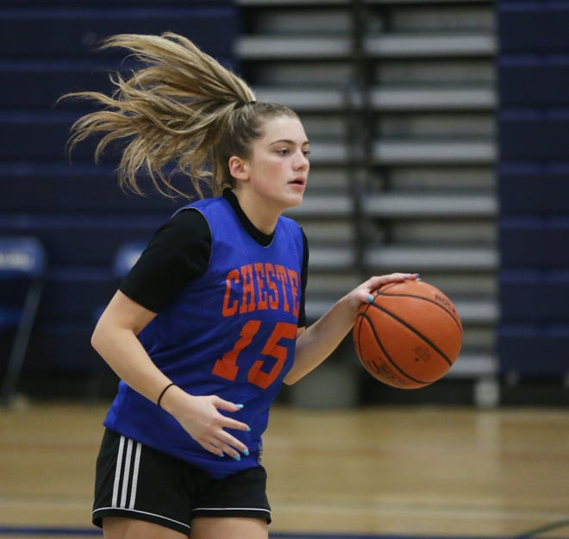
All-stars: Chester – Allison Bono, Sr.; Trinity Delgado, Sr.; Ellenville – Adriana Anderson, Sr.; Highland – Grace Koehler, Jr.; Danica Valente, Soph.; Marlboro – Gabriella Murphy; Hannah Polumbo; James I. O’Neill – Audrey Elisondo, Sr.; Daisy West, Jr.; Onteora – Paige Matteson; Red Hook – Katie Boyd, Jr.; Emilie Kent, Soph.; Rondout Valley – Maddie Malak, Sr.; Spackenkill – Tori Guy, Sr.; Blythe McQuade
Class C/D
Co-players of year: Shannon Sgombick (Seward) and Natalie Fox (Millbrook)
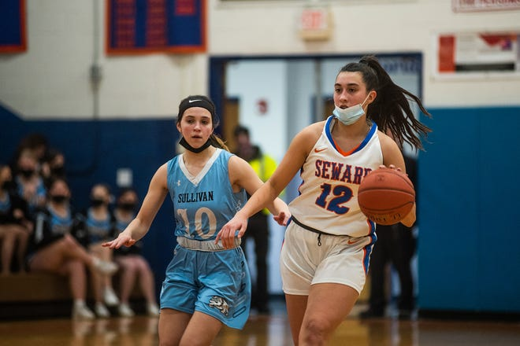
Coach of year: Joe DiMattina (S.S. Seward)
All-stars: John S. Burke Catholic – Michaela Byrons, Sr.; Livingston Manor – Mackenzie Carlson; Millbrook – Natalie Fox; Emily Grasseler; Ella Wilson; S.S. Seward – Shannon Sgombick, Sr.; Kayla Valenti, Sr.; Sullivan West – Elaine Herbert, Sr.; Tri-Valley – Jenna Carmody, Soph.

OCIAA coaches all-stars
Division 1
All-stars: Kingston – Diamond Banks, Jr.; Asia Lebon, Jr.; Ava Scaturro, Soph.; Middletown – Ashley MacCalla, Eighth; Sydney MacCalla, Soph.; Monroe-Woodbury – Arianna Exarchakis, Sr.; Madison Fileen, Sr.; Ella Natal, Sr.; Olivia Shippee, Sr.; Newburgh Free Academy – Terri-Nashjae (Titi) Burden, Fr.
Division 2
All-stars: Pine Bush – Ketura Rutty, Soph.; Jah-esa Stokes, Jr.; Leticia Watson, Soph.; Valley Central – Mackenzie Delmonico, Sr.; Giselle Johnson, Fr.; Warwick – Megan Desrats, Sr.; Paige Girardi, Sr.; Kaitlyn Larney, Soph.; Kiera Larney, Jr.; Washingtonville – Hannah Sullivan, Jr.
Division 3
All-stars: Beacon – Devyn Kelly, Jr.; Reilly Landisi, Soph.; Daveya Rodriguez, Soph.; Cornwall – Abby Walsh, Soph.; Maliha Yunker, Jr.; Goshen – Peyton Andryshak, Sr.; Emily Palau, Jr.; Minisink Valley – Casey Jennings, Sr.; Monticello – Aaliyah Mota, Sr.; Port Jervis – Penny Jones, Jr.
Division 4
All-stars: Chester – Allison Bono, Sr.; Trinity Delgado, Sr.; Christine Ravix, Sr.; Fallsburg – Maya Ballard, Soph.; Allison Perna, Sr.; Liberty – Emily Curry, Sr.; Angelica Rothberg, Jr.; James I. O’Neill – Audrey Elisondo, Sr.; Kate Feldman, Sr.; Daisy West, Jr.
Division 5
All-stars: John S. Burke Catholic – Michaela Byrons, Sr.; Rose Conlon, Sr.; S.S. Seward – Shannon Sgombick, Sr.; Kayla Valenti, Sr.; Sullivan West – Georgeanne Cardona, Sr.; Elaine Herbert, Sr.; Abby Parucki, Jr.; Tri-Valley – Jenna Carmody, Soph.; Mackenzie Closs, Sr.
Division 6
All-stars: Eldred – Olivia Gonzalez, Fr.; Rayanna Quintana, Jr.; Livingston Manor – Mackenzie Carlson, Sr.; Jocelyn Mills, Sr.; Roscoe – Zaylee Cox, Sr.; Ashlee Ladenhauf, Sr.

